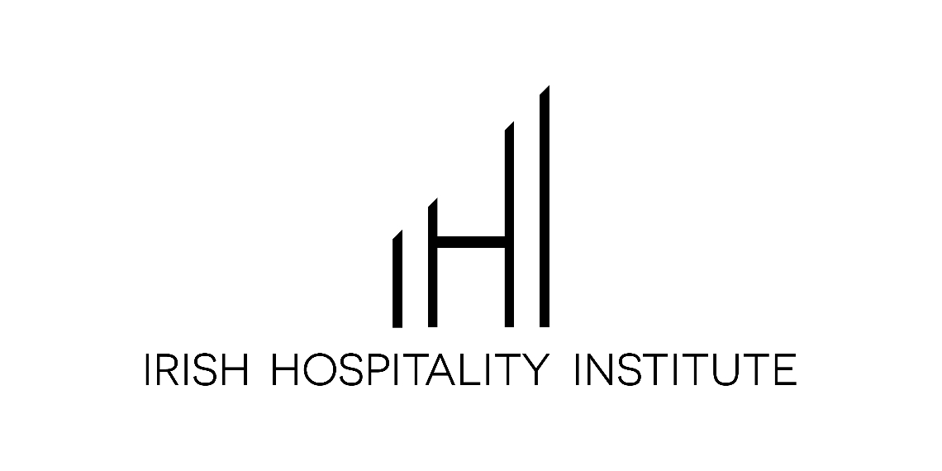

TU Dublin
School of Hospitality Management & Tourism
Wins the 35th
Irish Hospitality Institute
National Hospitality Business Management Game 2020

Supported by



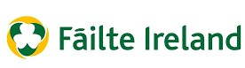

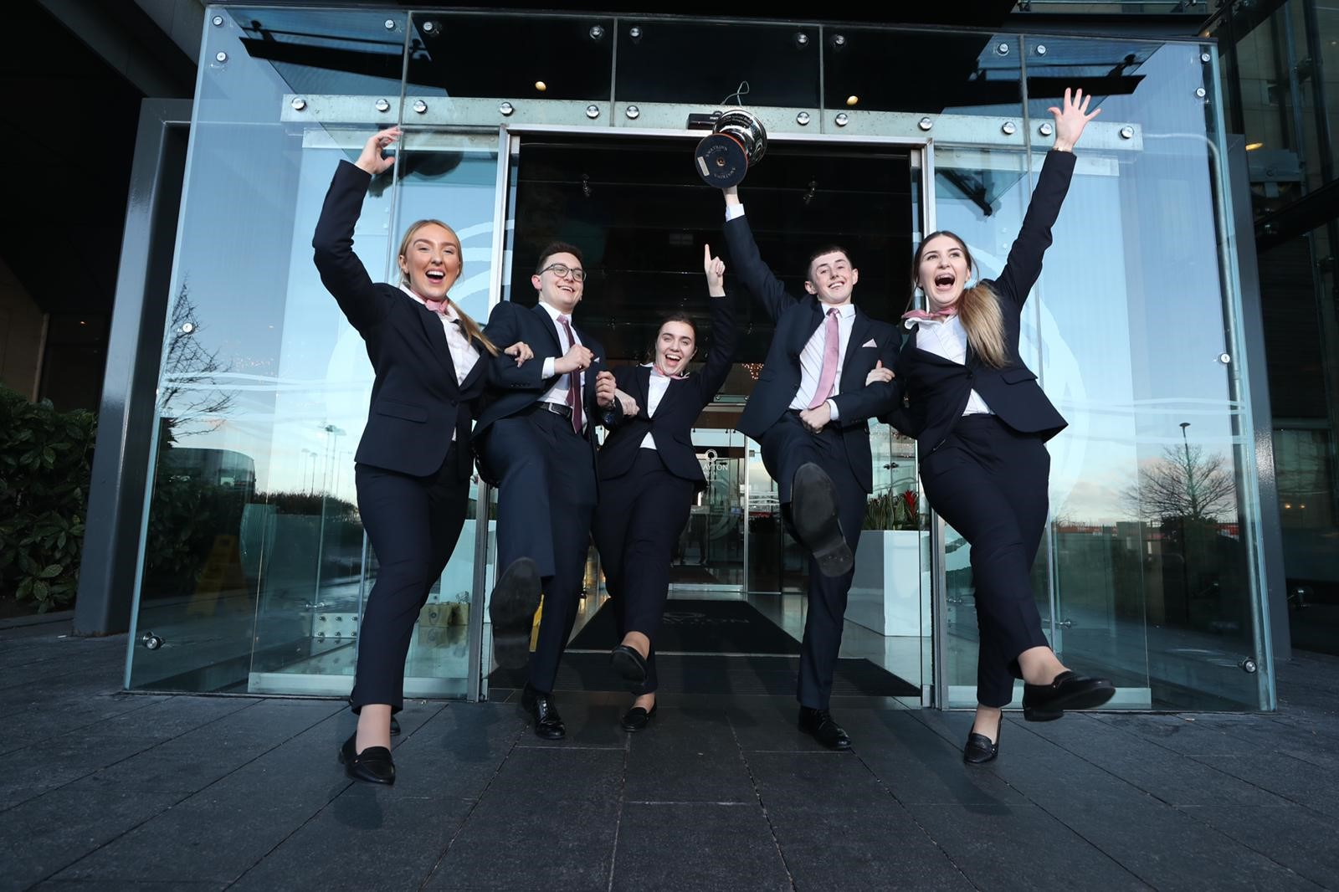

Left to right: Amie Kinsella, Charbel Yazbeck, Sarah Kenny, Dylan Leon and Ina Bivol.
Clayton Hotel, Dublin Airport 2nd March 2020
Tina Maree
Irish Hospitality Institute
+353-1-662-4790
Tina.Maree@ihi.ie

Cynthia O’Neill
Irish Hospitality Institute
353-1-662-4790
Cynthia.oneill@ihi.ie

A team of 5 students representing TU Dublin School of Hospitality Management & Tourism were selected as the outright winners of the 35th Irish Hospitality Institute (IHI) National Hospitality Business Management Game 2020 at the Clayton Hotel, Dublin Airport.
The winning team scored top marks in the competition that attracted six teams representing, Shannon College of Hotel Management, Galway & Mayo Institute of Technology, TU Dublin School of Hospitality & Tourism, Institute of Technology Dundalk and Institute of Technology Tralee.

1st TU Dublin School of Hospitality Management & Tourism
2nd Shannon College of Hotel Management
3rd Institute of Technology Dundalk

The Game supported by Dalata Hotel Group and Failte Ireland saw the teams complete 3 Challenges which tested the Students, business acumen and management skills in the areas of Business Development strategy, Revenue management and Human Resource management.

IHI President Oonagh Cremins said “Today our industry witnessed the talent and potential of the next generation of Young Hospitality Managers” The Hospitality Industry provides young graduates with real career opportunities to explore and develop in so many aspects of business: Sales and Marketing, Revenue Management, Finance, Human Resources, Training & Development and Operations: Proving the Hospitality Industry is dynamic and great place to work.

**Ends**

About Irish Hospitality Institute
The Irish Hospitality Institute (IHI) is a professional membership body representing over 1,000 Hospitality Professionals throughout Ireland.
The role of the IHI is to assist and encourage members to take responsibility for their own development, to facilitate networking, recognition and career advancement and to promote excellence in the hospitality industry.
To learn more about the Irish Hospitality Institute, visit www.IHI.ie or call +353 01-662 4790, connect on Facebook, LinkedIn and Twitter.

